***BRAINWORKS PYTHON-INTERNSHIP ASSIGNMENT***

***TASK-1 :***

**First of all I want to make you familiar with the module I have used in this task, here I have used the ‘nsetool’ module , ‘nsetool’ stands for National Stock Exchange Tool.**

**‘nsetools’ is a library for collecting real time data from National Stock Exchange of India. It can be used in various types of projects which requires fetching live quotes for a given stock or index or building large data sets for further data analytics. We can also build command line interface applications which can provide us live market details at a blazing fast speeds, much faster than any browser. The accuracy of data is only as correct as provided on** [**http://www.nseindia.com**](http://www.nseindia.com)**.**

**Screenshot of my code for task 1 is given below:**

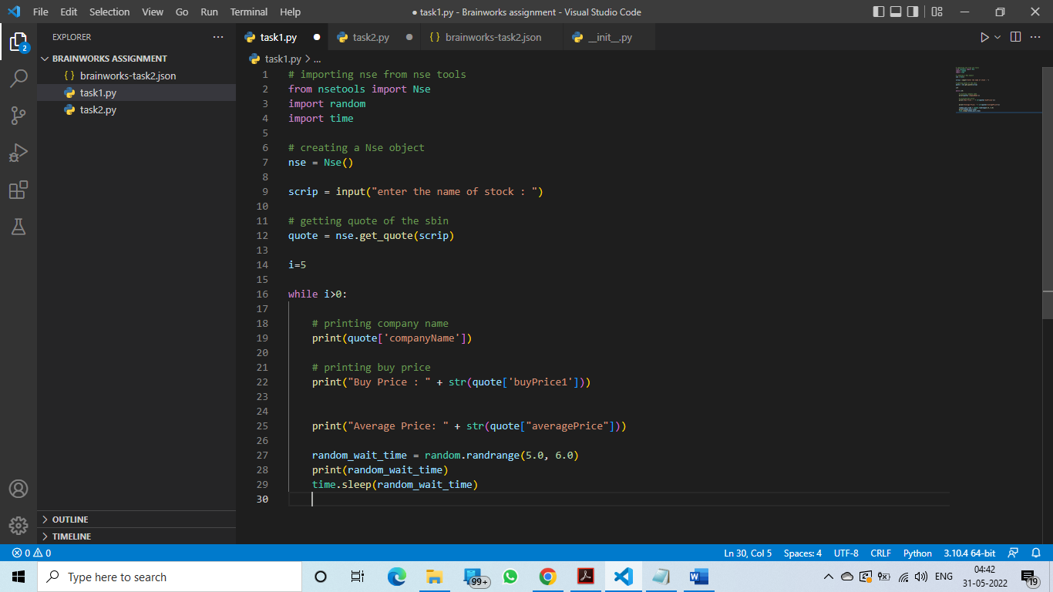

**STEPS TO RUN THE PROGRAM :**

* **Open the code provided in the google form , named as – Task1.py.**
* **Now install the ‘nsetool’ pip file by typing the command- [pip install nsetool] , in the terminal.**
* **Now, simply run the code using python interpreter.**
* **It will ask you the name of the stock, just enter it manually and hit enter.**
* **It will provide the buy price and the average price of the given stock and update after every 5 seconds.**

**Output of the task-1 is given below:**

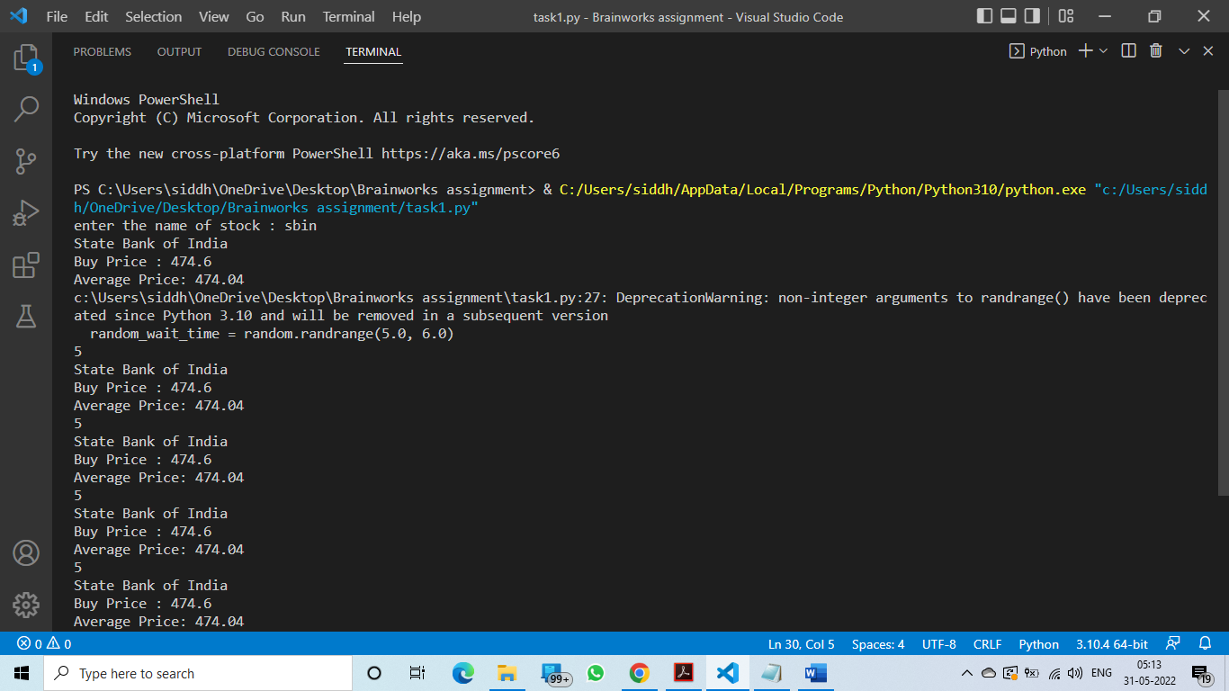

***TASK-2 :***

**Now, in task2 I will introduce you with the module related with the google spreadsheet which we have to use in the given task.**

1. **‘gspread’ is a Python API for Google Sheets.**

**Features:**

* **Google Sheets API v4.**
* **Open a spreadsheet by title, key or url.**
* **Read, write, and format cell ranges.**
* **Sharing and access control.**
* **Batching updates.**

**Screenshot of task-2 code is given below:**

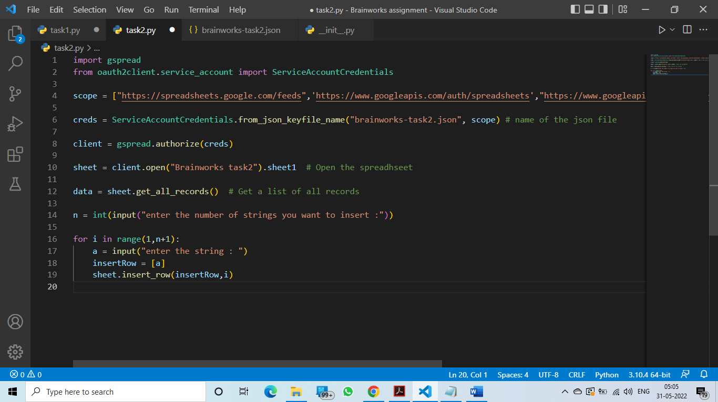

***STEPS TO RUN THE PROGRAM:***

* ***Open the link in your machine which is provided in the google form:*** [***https://docs.google.com/spreadsheets/d/1JvxZUFEW3ZnWHym5DVMfiNVAeXgN27VCh9moFK5Hjc4/edit?usp=sharing***](https://docs.google.com/spreadsheets/d/1JvxZUFEW3ZnWHym5DVMfiNVAeXgN27VCh9moFK5Hjc4/edit?usp=sharing)
* ***Now open the code named - task2.py provided in the google form and also the json file named- brainworks - task2 provided in the google form.***
* ***Must remember that you have to keep the json file in the same folder as task2.py.***
* ***Now run the task2.py, first it will ask you , how many number of columns you want to edit.***
* ***Then , write all the strings for column A.***
* ***You will get the required result in the google spreadsheet.***

***Output of the above task is given below:***

***Terminal (input):***

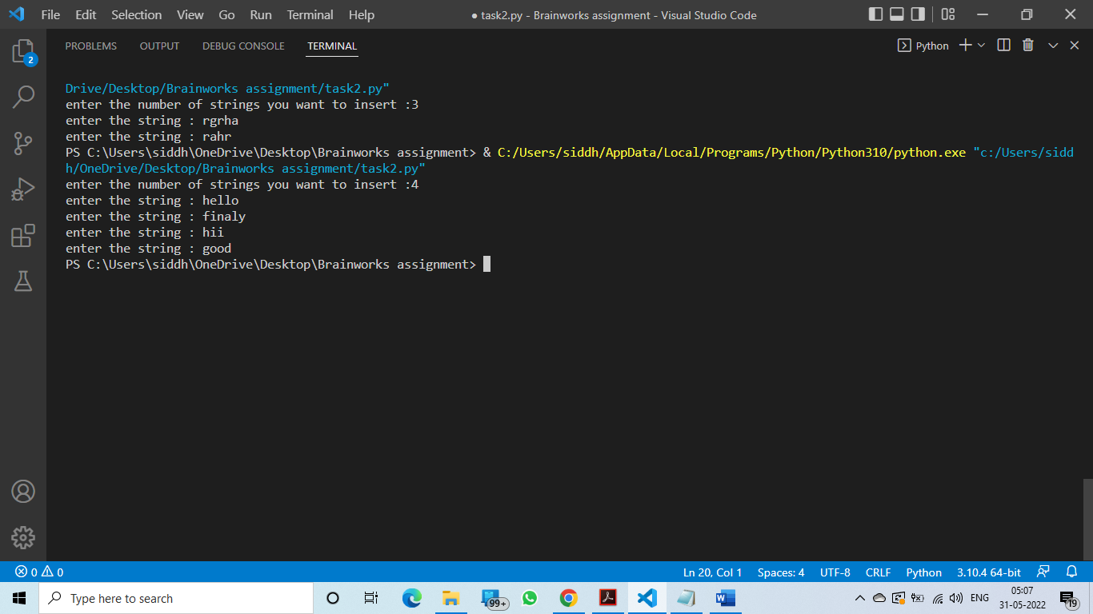

***Google spreadsheet (output):***

